Chapter 06: User Registration

User registration is a core feature in any dynamic website. And it will be in our Bookstore project, too. In this chapter we will implement log in, log out, and sign up functionality. The first two are relatively straightforward since Django provides us with the necessary views and urls for them, however sign up is more challenging since there is no built-in solution.

Auth App
Let’s begin by implementing log in and log out using Django’s own auth app. Django provides us with the necessary views and urls which means we only need to update a template for things to work. This saves us a lot of time as developers and it ensures that we don’t make a mistake since the underlying code has already been tested and used by millions of developers. However this simplicity comes at the cost of feeling “magical” to Django newcomers. We covered some of these steps previously in my book, Django for Beginners, but we did not slow down and look at the underlying source code. That book demonstrated “how” to implement user registration properly but did not do a deep dive into the “why.” Since this is a more advanced book, we will dive deeper to understand the underlying source code. The approach here can also be used to explore any other built-in Django functionality on your own.

The first thing we need to do is make sure the auth app is included in our INSTALLED_APPS setting. We have added our own apps here previously, but have you ever taken a close look at the built-in apps Django adds automatically for us? Most likely the answer is no. Let’s do that now!
# django_project/settings.py
INSTALLED_APPS = [
"django.contrib.admin",
"django.contrib.auth", # Yoohoo!!!!
"django.contrib.contenttypes",
"django.contrib.sessions",
"django.contrib.messages",
"django.contrib.staticfiles",
# Local
"accounts.apps.AccountsConfig",
"pages.apps.PagesConfig",
]

There are, in fact, 6 apps already there that Django provides for us which power the site. The first is admin and the second is auth. This is how we know the auth app is already present in our Django project.

When we earlier ran the migrate command for the first time all of these apps were linked together in the initial database. And remember that we used the AUTH_USER_MODEL setting to tell Django to use our custom user model, not the default User model here. This is why we had to wait until that configuration was complete before running migrate for the first time.

Auth URLs and Views
To use Django’s built-in auth app we must explicitly add it to our config/urls.py file. The easiest approach is to use accounts/ as the prefix since that is commonly used in the Django community. Make the one line change below. Note that as our urls.py file grows in length, adding comments for each type of URL–admin, user management, local apps, etc.–helps with readability.
# django_project/urls.py
from django.contrib import admin
from django.urls import path, include

urlpatterns = [
# Django admin
path("admin/", admin.site.urls),
# User management
path("accounts/", include("django.contrib.auth.urls")), # new
# Local apps
path("", include("pages.urls")),
]
What’s included in the auth app? A lot it turns out. First off, there are a number of associated urls.
Code
accounts/login/ [name="login"]
accounts/logout/ [name="logout"]
accounts/password_change/ [name="password_change"]
accounts/password_change/done/ [name="password_change_done"]
accounts/password_reset/ [name="password_reset"]
accounts/password_reset/done/ [name="password_reset_done"]
accounts/reset/<uidb64>/<token>/ [name="password_reset_confirm"]
accounts/reset/done/ [name="password_reset_complete"]

How did I know that? Two ways. The first is the official auth docs tell us so! But a second, deeper approach is to look at the Django source code which is available on Github. If we navigate or search around we’ll find our way to the auth app itself. And within that we can find the urls.py file at this link which shows the complete source code.

It takes practice to understand the Django source code, but it is well worth the time.

Homepage
What’s next? Let’s update our existing homepage so that it will notify us if a user is already logged in or not which currently can only happen via the admin.
Here is the new code for the templates/home.html file. It uses the Django templating engine’s if/else tags for basic logic.
<!-- templates/home.html -->
{% extends "_base.html" %}

{% block title %}Home{% endblock title %}

{% block content %}
<h1>This is our home page.</h1>
{% if user.is_authenticated %}
<p>Hi {{ user.email }}!</p>
{% else %}
<p>You are not logged in</p>
<a href="{% url 'login'%}">Log In</a>
{% endif %}
{% endblock content %}

If the user is logged in (authenticated), we display a greeting that says “Hi” and includes their email address. These are both variables which we can use with Django’s template engine via double opening {{ and closing }} brackets.

The default User contains numerous fields including is_authenticated and email which are referenced here. And the logout and login are URL names. The url template tag means if we specify the URL name the link will automatically refer to that URL path. For example, in the previous chapter we set the URL name for the homepage to home, which means a homepage link would take the format of {% url 'home' %}. More on this shortly.

If you look at the homepage now at http://127.0.0.1:8000/ it will likely show the email address of your superuser account since we used it previously to log in.
Homepage with greeting

In the admin over at http://127.0.0.1:8000/admin/, if you click on the “Log out” button in the upper right corner we can log out of the admin and by extension the Django project. Return to the homepage at http://127.0.0.1:8000/ and refresh the page.
Admin logout link

Django Source Code
You might have been able to piece together these steps on your own from reading the official docs. But the deeper–and better–approach is to learn how to read the Django source code on your own.

One question is, how was the user and its related variables magically available in our template? The answer is that Django has a concept called the template context which means each template is loaded with data from the corresponding views.py file. We can use user within template tags to access User attributes. In other words, Django just gives this to us automatically.

So to check if a user is logged in or not, we access user and then can use the boolean
is_authenticated attribute. If a user is logged in, it will return True and we can do things like display the user’s email. Or if no user is logged in, the result will be False.

Moving on we have the URL name login. Where did that come from? The answer, of course, is from Django itself! Let’s unpack the code snippet {% url 'login' %} piece by piece.

First up we’re using the url template tag which takes as its first argument a named URL pattern. That’s the optional name section we add as a best practice to all our URL paths. Therefore there must be a 'login' name attached to the URL used by Django for log ins, right!

There are two ways we could have known this. In other words, if I hadn’t just told you that we wanted to use {% url 'login' %}, how could you have figured it out?
First look at the official documentation. Personally I often use the search feature so I would have typed in something like “login” and then clicked around until I found a description of log in. The one we want is actually called authentication views and lists the corresponding URL patterns for us.
Code
accounts/login/ [name="login"]
accounts/logout/ [name="logout"]
accounts/password_change/ [name="password_change"]
accounts/password_change/done/ [name="password_change_done"]
accounts/password_reset/ [name="password_reset"]
accounts/password_reset/done/ [name="password_reset_done"]
accounts/reset/<uidb64>/<token>/ [name="password_reset_confirm"]
accounts/reset/done/ [name="password_reset_complete"]

This tells us at the path accounts/login/ is where “login” is located and its name is 'login'. A little confusing at first, but here is the info we need.

Going a step deeper to phase two, we can investigate the underlying Django source code to see “logout” in action. If you perform a search over on Github you’ll eventually find the auth app itself. Ok, now let’s start by investigating the urls.py file. Here is the link to the complete code:
# django/contrib/auth/urls.py
from django.contrib.auth import views
from django.urls import path

urlpatterns = [
path('login/', views.LoginView.as_view(), name='login'),
path('logout/', views.LogoutView.as_view(), name='logout'),

path('password_change/', views.PasswordChangeView.as_view(),
name='password_change'),
path('password_change/done/', views.PasswordChangeDoneView.as_view(),
name='password_change_done'),
path('password_reset/', views.PasswordResetView.as_view(),
name='password_reset'),
path('password_reset/done/', views.PasswordResetDoneView.as_view(),
name='password_reset_done'),
path('reset/<uidb64>/<token>/', views.PasswordResetConfirmView.as_view(),
name='password_reset_confirm'),
path('reset/done/', views.PasswordResetCompleteView.as_view(),
name='password_reset_complete'),
]

Here is the underlying code Django uses itself for the auth app. I hope you can see that the “logout” route is not magic. It’s right there in plain sight, it uses the view LogoutView and has the URL name 'logout'. Not magic at all! Just a little challenging to find the first time.

This three-step process is a great way to learn: either remember the Django shortcut, look itup in the docs, or on occasion dive into the source code and truly understand where all this goodness comes from.

Log In
Back on our basic homepage, click on the “Log In” link and… it results in an error!
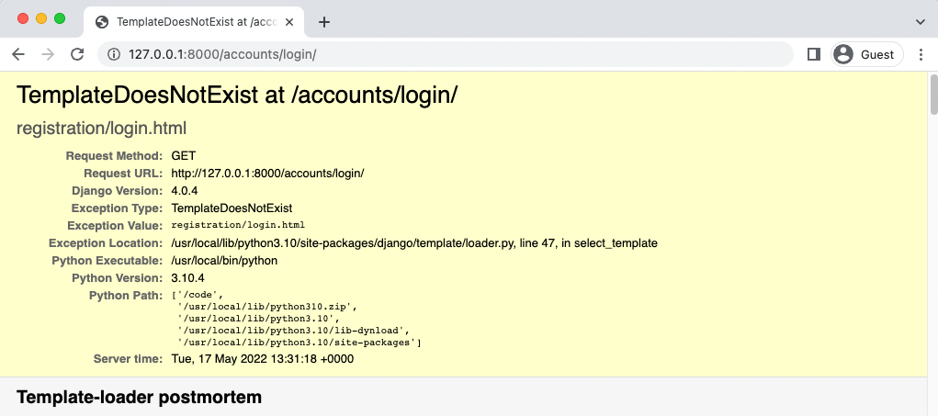
TemplateDoesNotExist error

Django is throwing a TemplateDoesNotExist error at us. Specifically, it seems to expect a log in template at registration/login.html. In addition to Django telling us this, we can look in the documentation and see that the desired template_name has that location.

But let’s really be sure and check the source code so we can remove any perceived magic here. After all, it’s just Django.

Back in the auth/views.py file we can see on line 47 for LoginView that the template_name is 'registration/login.html'. So if we wanted to change the default location we could, but it would mean overriding LoginView which seems like overkill. Let’s just use what Django gives us here.

Create a new registration folder within the existing templates directory.
mkdir templates/registration

Then in your text editor create a login.html file within the templates/registration directory. The actual code is as follows. We extend our base template, add a title, and then specify that we want to use a form that will “post” or send the data.
<!-- templates/registration/login.html -->
{% extends "_base.html" %}

{% block title %}Log{% endblock title %}

{% block content %}
<h2>Log In</h2>
<form method="post">
{% csrf_token %}
{{ form.as_p }}
<button type="submit">Log In</button>
</form>
{% endblock content %}

You should always add CSRF protection on any submittable form. Otherwise a malicious website can change the link and attack the site and the user. Django has CSRF middleware to handle this for us; all we need to do is add {% csrf_token %} tags at the start of the form.

Next we can control the look of the form contents. For now we’ll use as_p() so that each form field is displayed within a paragraph p tag.

With that explanation out of the way, let’s check if our new template is working correctly. Refresh the web page at http://127.0.0.1:8000/accounts/login/.
Log in page

And there is our page! Lovely. You can navigate back to the homepage and confirm that the “Log In” link works, too, if you like. As a final step, go ahead and try to log in with your superuser account on the log in page.

Redirects
Did you notice I said “try” in that last sentence? If you click on the “Log In” link it brings up a Page not found (404) error.
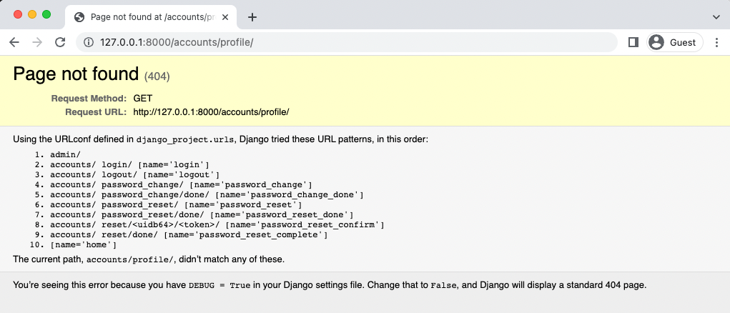
Page not found error
Django has redirected us to 127.0.0.1:8000/accounts/profile/ yet no such page exists. Now why would Django do this? Well, if you think about it, how does Django know where we want to redirect the user after log in? Maybe it’s the homepage. But maybe it’s a user profile page. Or any number of options.

The final piece of the log in puzzle is to set the proper configuration for LOGIN_REDIRECT_URL because by default it redirects to accounts/profile.

Fortunately, this is a quick fix. We’ll send the user to our homepage. And since we specified a URL name of home that’s all we need to redirect logged in users to the homepage.

At the bottom of the django_project/settings.py file add this one line.
# django_project/settings.py
LOGIN_REDIRECT_URL = "home" # new

Attempt to log in again at http://127.0.0.1:8000/accounts/login/. Upon success it redirects the user to the homepage greeting the superuser account you just logged in with!
Homepage logged out

Log Out
Now let’s add a log out option to our homepage since only a superuser will have access to the admin. How do we do this?

If you look at the auth views above we can see that logout uses LogoutView, which we could explore in the source code, and has a URL name of logout. That means we can refer to it with a template tag as just logout.

But we can set this ourself, if desired, using LOGOUT_REDIRECT_URL which can be added to the bottom of our django_project/settings.py file. Let’s do that so a logged out user is redirected to the homepage.
# django_project/settings.py
LOGIN_REDIRECT_URL = "home"
LOGOUT_REDIRECT_URL = "home" # new

Then add the logout link to templates/home.html.

<!-- templates/home.html -->
{% extends "_base.html" %}

{% block title %}Home{% endblock title %}

{% block content %}
<h1>This is our home page.</h1>
{% if user.is_authenticated %}
<p>Hi {{ user.email }}!</p>
<p><a href="{% url 'logout' %}">Log Out</a></p> # new
{% else %}
<p>You are not logged in</p>
<a href="{% url 'login'%}">Log In</a>
{% endif %}
{% endblock content %}

Refresh the homepage at http://127.0.0.1:8000/ and the “Log out” link is now visible.
Homepage with logout link

If you click on it you will be logged out and redirected to the homepage, which has the “Log In” link visible.
Homepage with login link

Sign Up
Implementing a sign up page for user registration is completely up to us. We’ll go through the standard steps for any new page:

• create an app-level accounts/urls.py file
• update the project-level django_project/urls.py to point to the accounts app
• add a view called SignupPageView
• create a signup.html template file
• update home.html to display the sign up page

A common question is: what’s the right order for implementing these steps? Honestly, it doesn’t matter since we need all of them for the sign up page to work properly. I know it would be more comforting if there was a prescribed order but each is a puzzle piece that fits together in their entirety. That said, I generally like to start with urls, then switch to views, and finally templates but it’s a matter of personal preference.

To start use your text editor to create an accounts/urls.py file. Up to this point the accounts app has only contained our CustomUser in the models.py file; we haven’t configured any routes or views.

The URL path for the sign up page will take a view called SignupPageView (which we’ll create next), at the route signup/, and have a name of signup which we can later use to refer to the page with a url template tag. The existing url names for login and signup are written within the built-in Django app file django/contrib/auth/urls.py we saw above.
# accounts/urls.py
from django.urls import path
from .views import SignupPageView

urlpatterns = [
path("signup/", SignupPageView.as_view(), name="signup"),
]

Next update the django_project/urls.py file to include the accounts app. We can create any route we like but it’s common to use the same accounts/ one used by the default auth app. Note that it’s important to include the path for accounts.urls below: URL paths are loaded top-tobottom so this ensures that any built-in auth app URL paths will be loaded first.
# django_project/urls.py
from django.contrib import admin
from django.urls import path, include # new

urlpatterns = [
# Django admin
path('admin/', admin.site.urls),
# User management
path("accounts/", include("django.contrib.auth.urls")), # new
# Local apps
path("accounts/", include("accounts.url")), # new
path("", include("pages.urls")),
]
Now create the view SignupPageView. It references the CustomUserCreationForm and has a success_url that points to the login page, meaning after the form is submitted the user will be redirected there. The template_name will be signup.html.
# accounts/views.py
from django.urls import reverse_lazy
from django.views import generic
from .forms import CustomUserCreationForm

# Create your views here.
class SignupPageView(generic.CreateView):
form_class = CustomUserCreationForm
success_url = reverse_lazy("login")
template_name = "registration/signup.html"

As a final step create a file called templates/registration/signup.html which will contain code basically identical to the log in page.
<!-- templates/registration/signup.html -->
{% extends "_base.html" %}

{% block title %}Sign Up{% endblock title %}

{% block content %}
<h2>Sign Up</h2>
<form method="post">
{% csrf_token %}
{{ form.as_p }}
<button type="submit">Sign Up</button>
</form>
{% endblock content %}

As a final step we can add a line for “Sign Up” to our home.html template right below the link for “Log In”. This is a one-line change.
<!-- templates/home.html -->
{% extends "_base.html" %}

{% block title %}Home{% endblock title %}

{% block content %}
<h1>This is our home page.</h1>
{% if user.is_authenticated %}
<p>Hi {{ user.email }}!</p>
<p><a href="{% url 'logout' %}">Log Out</a></p>
{% else %}
<p>You are not logged in</p>
<a href="{% url 'login'%}">Log In</a>
<a href="{% url 'signup' %}">Sign Up</a> # new
{% endif %}
{% endblock content %}

All done! Reload the homepage to see our work.
Homepage with Signup

The “Sign Up” link now redirects to the webpage http://127.0.0.1:8000/accounts/signup/.
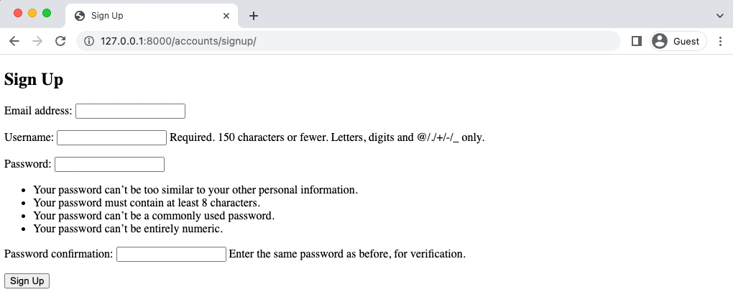
Signup page

Create a new user with the email address testuser@email.com, username of testuser, and testpass123 for the password. Upon submission it will redirect us to the Log In page. Log in with the new account and it redirects to the homepage with a personalized greeting.
Homepage with testuser greeting
Tests
For tests we do not need to test log in and log out features since those are built into Django and already have tests. We do need to test our sign up functionality though!

Let’s start by creating a setUpTestClass method that loads our page. Then we’ll populate test_signup_template with tests for the status code, template used, and both included and excluded text similarly to how we did it in the last chapter for the homepage.

In your text editor, update the accounts/tests.py file with these changes.
# accounts/tests.py
from django.contrib.auth import get_user_model
from django.test import TestCase
from django.urls import reverse # new

# Create your tests here.
class CustomUserTests(TestCase):
…

class SignupPageTest(TestCase): # new
def setUp(self):
url = reverse("signup")
self.response = self.client.get(url)

def test_signup_template(self):
self.assertEqual(self.response.status_code, 200)
self.assertTemplateUsed(self.response, "registration/signup.html")
self.assertContains(self.response, "Sign Up")
self.assertNotContains(self.response, "Hi there! I should not be on the page.")

Then run our tests.
docker-compose exec web python manage.py test
Creating test database for alias 'default'...
System check identified no issues (0 silenced).
........
----------------------------------------------------------------------
Ran 8 tests in 0.148s
OK
Destroying test database for alias 'default'...

Next we can test that our CustomUserCreationForm is being used and that the page resolves to SignupPageView.
# accounts/tests.py
from django.contrib.auth import get_user_model
from django.test import TestCase
from django.urls import reverse, resolve # new
from .forms import CustomUserCreationForm # new
from .views import SignupPageView # new

# Create your tests here.
class CustomUserTests(TestCase):
…

class SignupPageTest(TestCase): # new
def setUp(self):
url = reverse("signup")
self.response = self.client.get(url)

def test_signup_template(self):
self.assertEqual(self.response.status_code, 200)
self.assertTemplateUsed(self.response, "registration/signup.html")
self.assertContains(self.response, "Sign Up")
self.assertNotContains(self.response, "Hi there! I should not be on the page.")

def test_signup_form(self): # new
form = self.response.context.get("form")
self.assertIsInstance(form, CustomUserCreationForm)
self.assertContains(self.response, "csrfmiddlewaretoken")

def test_signup_view(self): # new
view = resolve("/accounts/signup/")
self.assertEqual(view.func.__name__, SignupPageView.as_view().__name__)

All done.

Git
As ever make sure to save our work by adding changes into Git.
git status
git add .
git commit -m “Chapter 06. User Registration”

To push to GitHub if you have an account:
1. run: cd ..
Your path should be where you root depository is(in my case Bookstore-by-Chapter):
PS C:\Users\computer’s username\Documents\your main folder\Bookstore-by-Chapter>
Yours would be different like:
PS C:\Users\computer’s username\Documents\your main folder\title of your subfolder>

git add "Chapter 06. User Registration"
git commit -m "Chapter 06. User Registration"
git push

Create a back up:
Copy-Item -Recurse -Path "C:\Users\Jean-Marc H\Documents\Django for professionals\Bookstore-by-Chapter\Chapter x. chapter’s title" -Destination "C:\Users\Jean-Marc H\Documents\Django for professionals\Bookstore-by-Chapter\ Chapter x. chapter’s title - Backup"
The official source code is located on Github if you want to compare your code.

Conclusion
Our Bookstore project is not the most beautiful site in the world, but it is very functional at this point. In the next chapter we’ll configure our static assets and add Bootstrap for improved styling.
The end

